- Show the charter trip number, date, and destination.
SELECT char_trip, char_date, char_destination from charter;
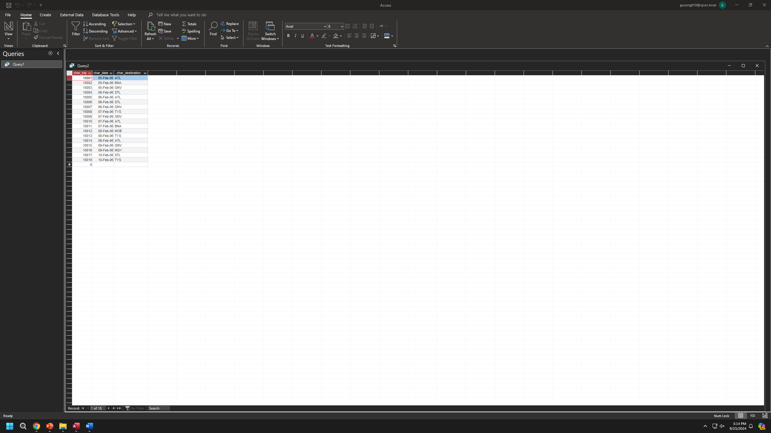
- Which charters are using the aircraft 2778V?
SELECT char_trip from charter where AC_NUMBER = "2778V";

- What are the average hours flown by aircraft going to “ATL” – Atlanta?
SELECT avg(CHAR_HOURS_FLOWN) AS
AVG_HOURS_FLOWN FROM CHARTER
WHERE CHAR_DESTINATION="ATL";

- How many flights are going to each city?
SELECT CHAR_DESTINATION, COUNT(*) AS number_of_flights
FROM charter
GROUP BY CHAR_DESTINATION;


- Which customers who went to ATL did not go to STL?
SELECT DISTINCT CUS_CODE
FROM charter
WHERE CHAR_DESTINATION = 'ATL'
AND CUS_CODE NOT IN (
SELECT CUS_CODE
FROM charter
WHERE CHAR_DESTINATION = 'STL');
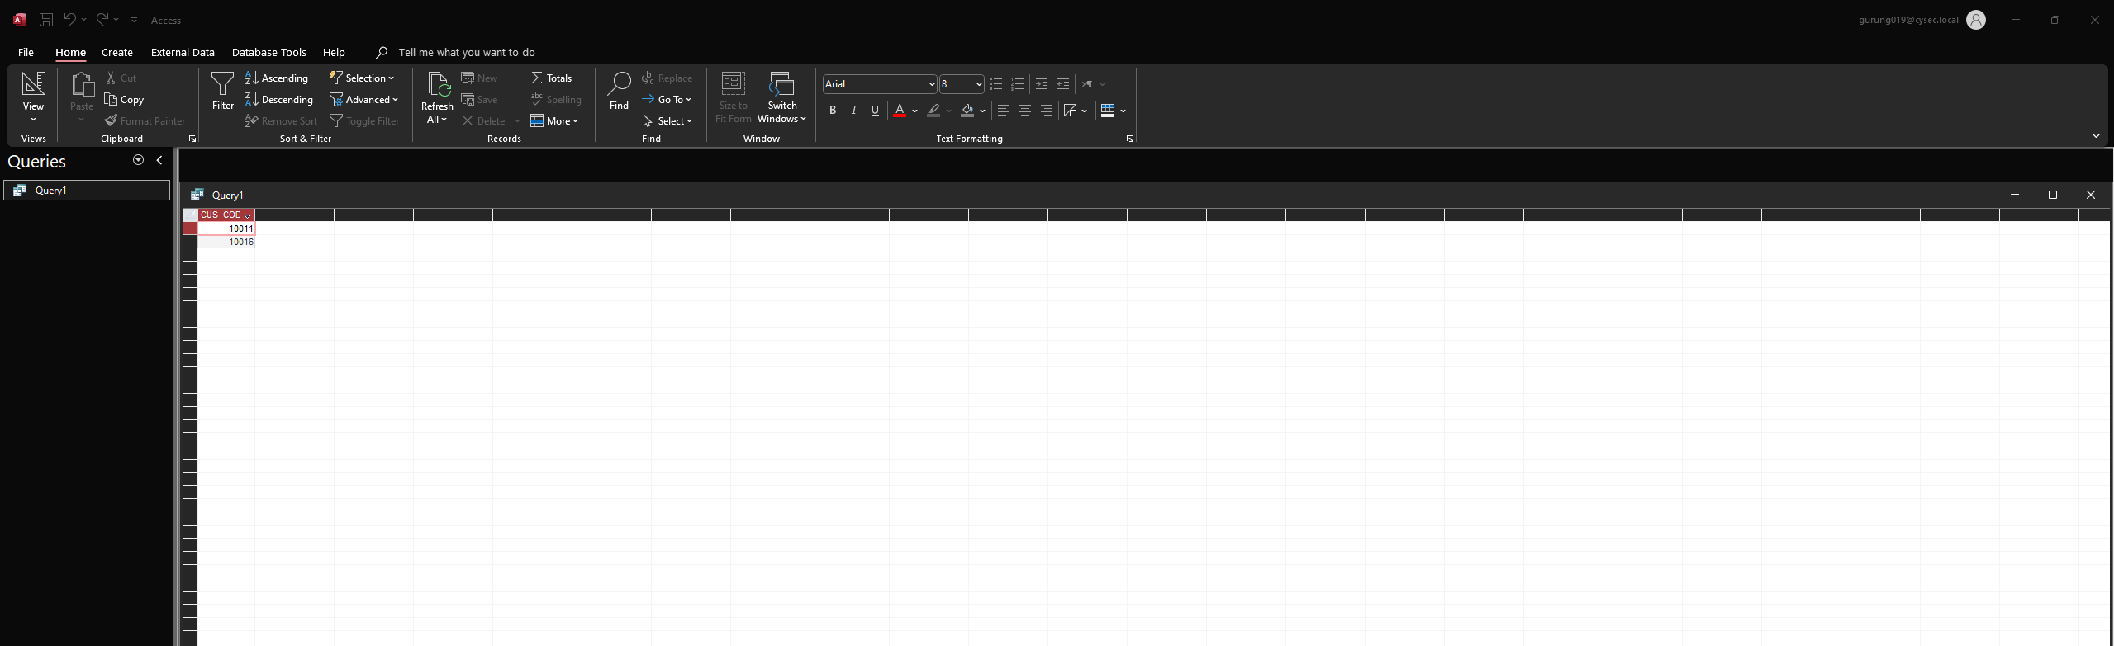
- Which customers who went to ATL did go to STL?
SELECT DISTINCT CUS_CODE
FROM charter
WHERE CHAR_DESTINATION = 'ATL'
AND CUS_CODE IN (
SELECT CUS_CODE
FROM charter
WHERE CHAR_DESTINATION = 'STL');
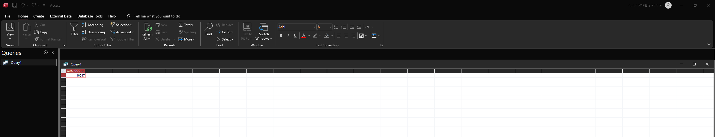
- Did any customers with an outstanding balance charter a flight on Feb. 5 or Feb. 6?
SElECT CU.CUS_CODE, CU.CUS_LNAME, CU.CUS_FNAME,
CU.CUS_BALANCE, CH.CHAR_DATE
FROM CUSTOMER AS CU
INNER JOIN CHARTER AS CH ON CU.CUS_CODE = CH.CUS_CODE
WHERE CU.CUS_BALANCE > 0
AND CH.CHAR_DATE IN (#2006-02-05#, #2006-02-06#);
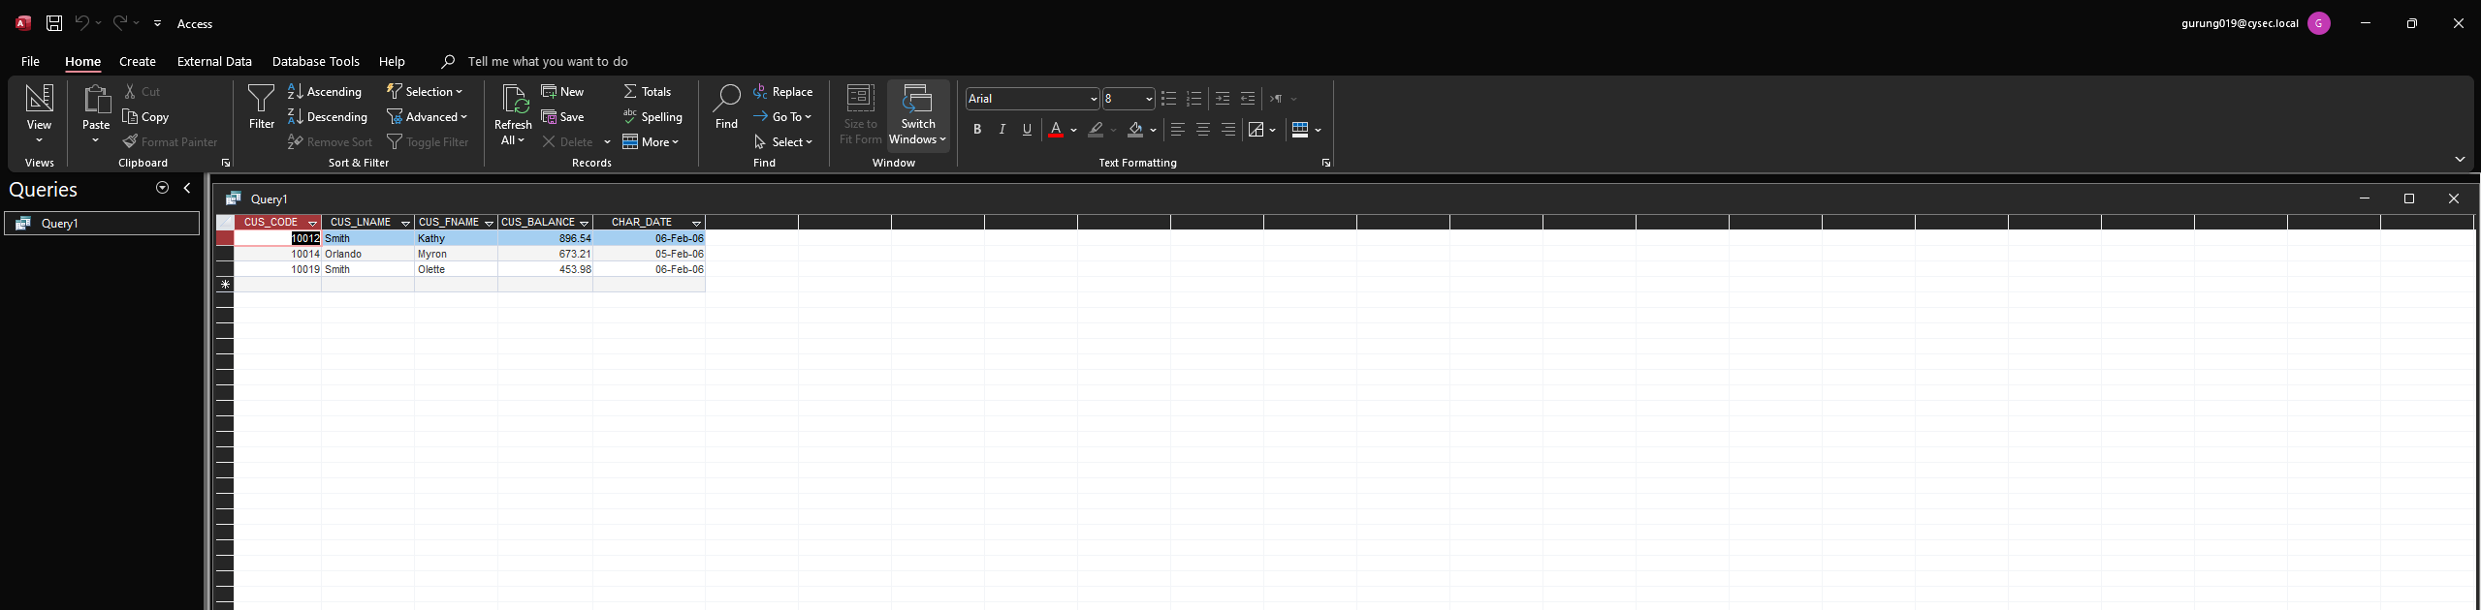

- How much is outstanding at the company?
SELECT SUM(CUS_BALANCE) AS total_outstanding
FROM customer;
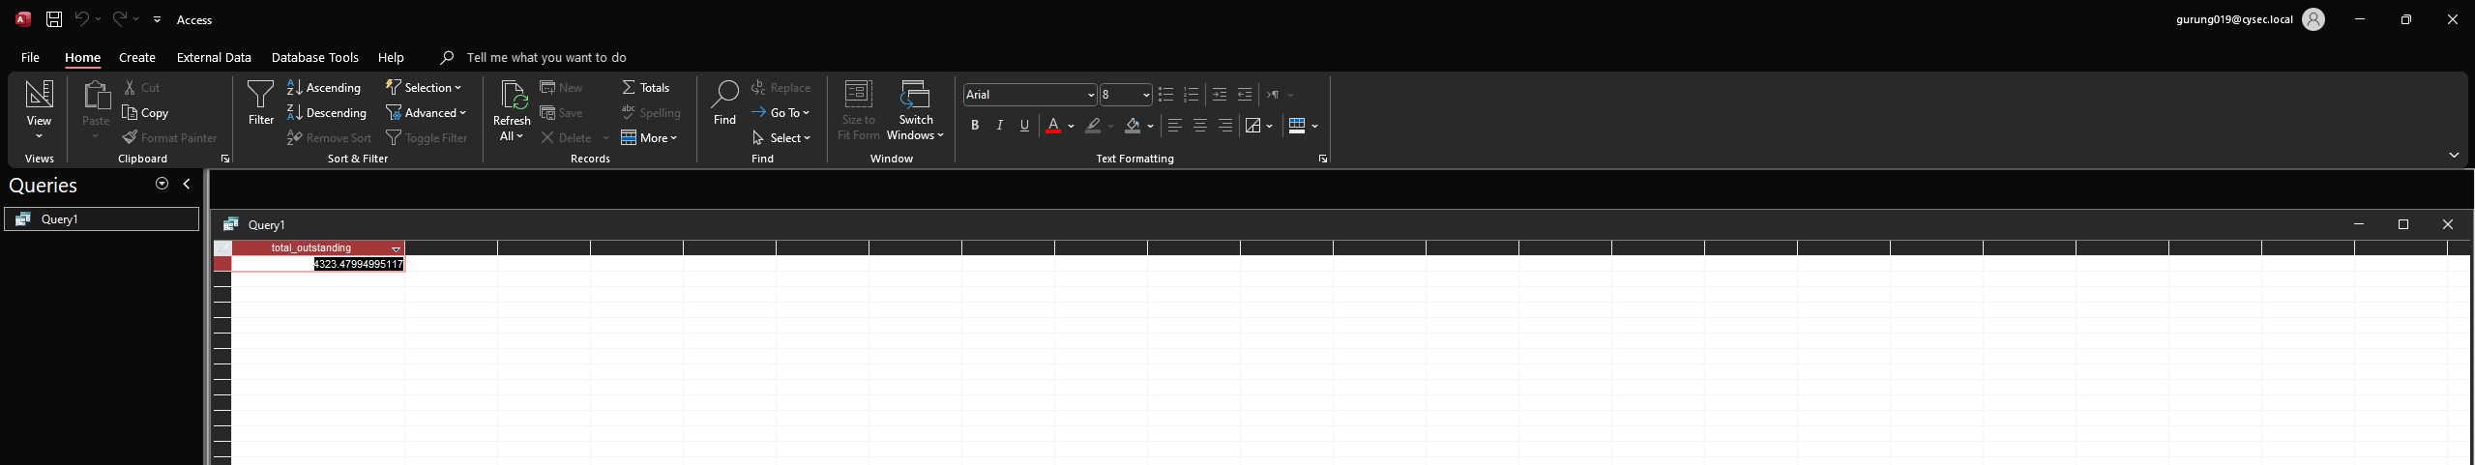

- What is the average charter distance?
SELECT AVG(CHAR_DISTANCE) AS average_distance
FROM charter;

- Who crewed the TYS charters?
SELECT *
FROM CHARTER,CREW
WHERE CHARTER.CHAR_TRIP=CREW.CHAR_TRIP
AND CHAR_DESTINATION='TYS';
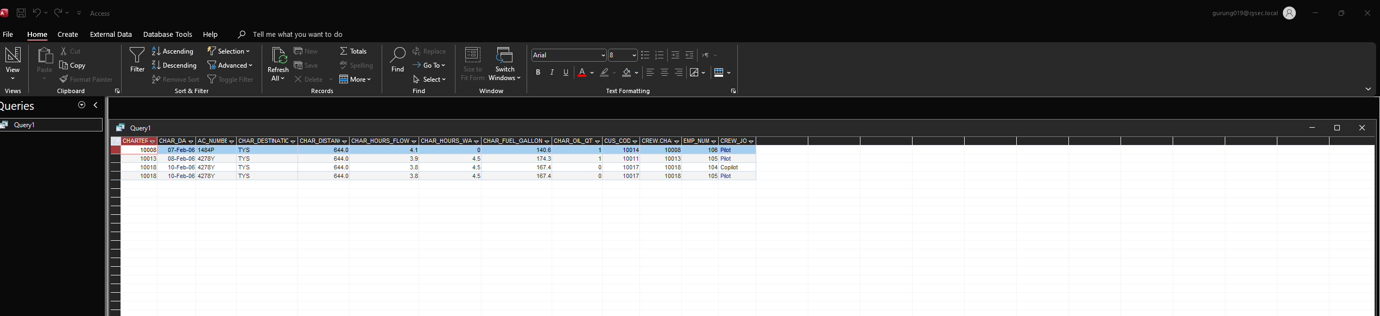

- What are the names of everyone involved in the TYS charters?
SELECT CHARTER.CHAR_TRIP, CHARTER.CHAR_DESTINATION,CREW.CREW_JOB,CUSTOMER.CUS_CODE,
CUSTOMER.CUS_FNAME,CUSTOMER.CUS_LNAME
FROM CHARTER,CREW,CUSTOMER
WHERE CHARTER.CHAR_TRIP=CREW.CHAR_TRIP
AND CHAR_DESTINATION='TYS'
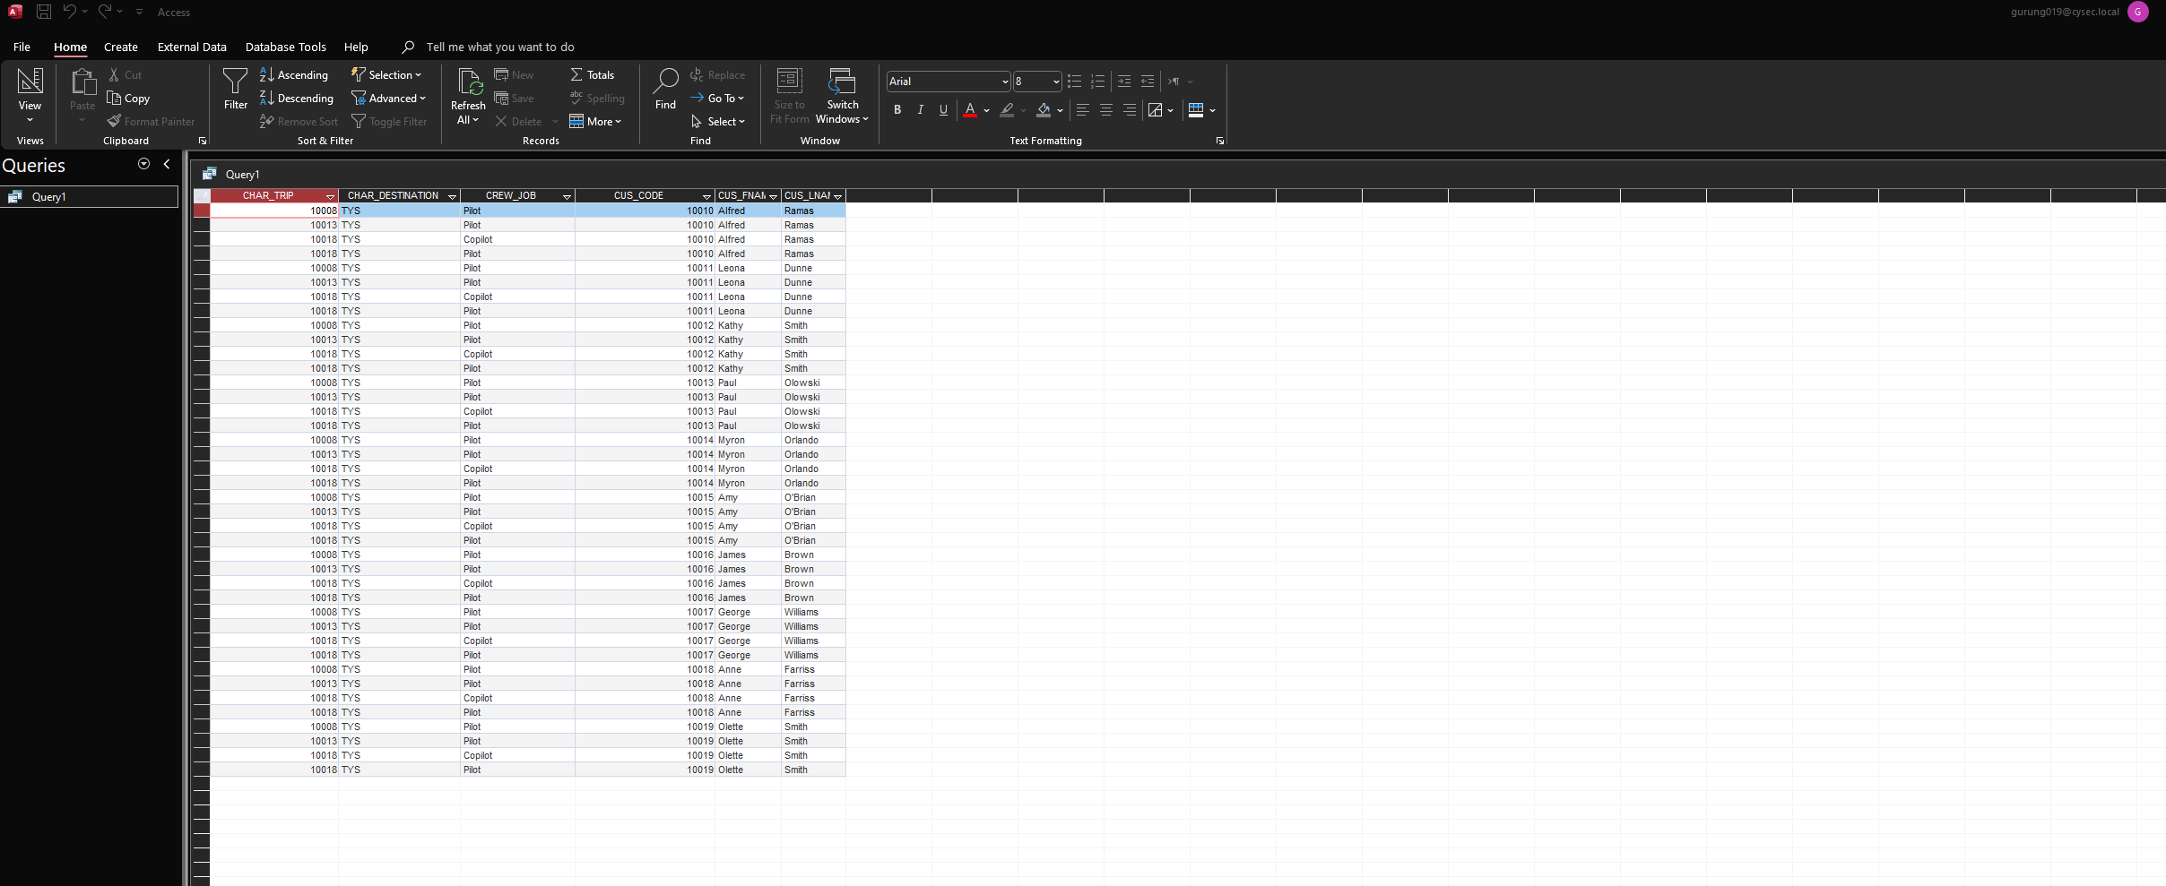

- What are the names of everyone involved in the TYS charters and their role (either CREW or PASSENGER)? Arrange the report by role with crew members first.
- What is the mileage charge for each flight flown after February 9? Note: “Charge per mile” is relative to the model; miles are an attribute of the charter. Show charter date, customer last name, charter distance, charge per mile, and mileage charge Arrange the above report so that the information displays dates in increasing fashion. Then, within dates, arrange by customer last name.
- Produce a similar chart showing “gallons per mile flown”.
- For the plane which flew the most miles, how old is its airframe, left engine, and right engine
- For this heavily used plane, its travels in February accounted for what fraction of its airframe age?

